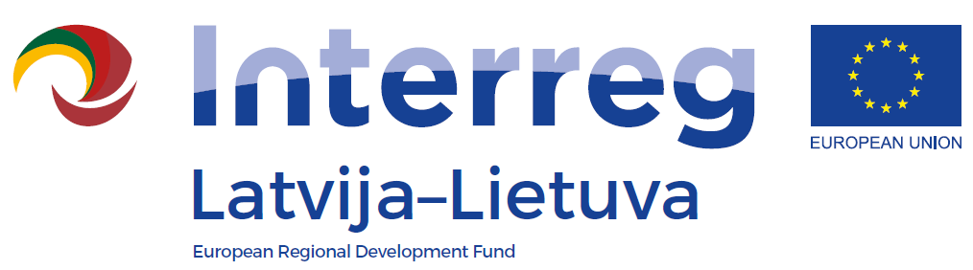
1st Call of the INTERREG V_A
Latvia-Lithuania Programme 2014-2020

LLI-110 Self-service libraries for different generations
Experience exchange trip to France
AGENDA
Date: 3rd – 5th October 2018
Venue: 6 Rue du Helder, Paris, France
3.10. | Arriva in Paris (France)
4.10.  9.⁰⁰ – 16.⁰⁰ | Public Library "Mediateca” Rueil-Malmaison  15-21 Boulevard du Maréchal Foch, 92500 Rueil-Malmaison, France  http://www.mediatheque-rueilmalmaison.fr/
5.10. | Departure from Paris (France)

