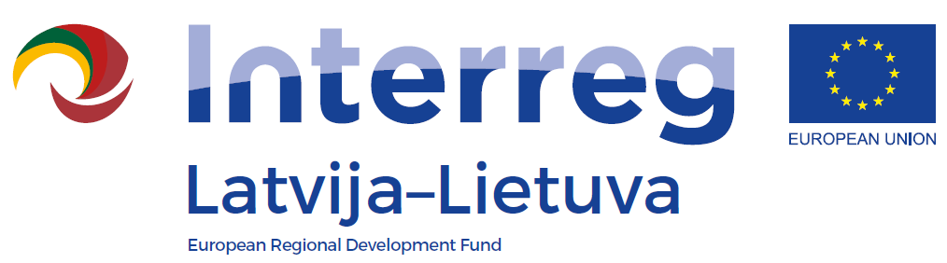
1st Call of the INTERREG V-A
Latvia-Lithuania Programme 2014-2020

LLI-110 Self-service libraries for different generations
Kick-off meeting
AGENDA
Date: 23 May 2017
Venue: Jelgava City library, Akademijas str. 26, Jelgava
11:30 – 12:00 | Arrival and registration
12:00 – 12:15 | Welcoming
12:15 – 13:30 | Information regarding project implementation:  - The project work plan  - Composition of the Project Management Group (PMG) and a Steering Committee (SC), further meetings of PMG and SC  - The communication plan  - Reporting requirements and deadlines
13:30 – 13:45 | Coffee break
13:45 – 15:00 | - Main activities and deliverables of 1st reporting period  - Common events for all partners within 1st reporting period  - Other

