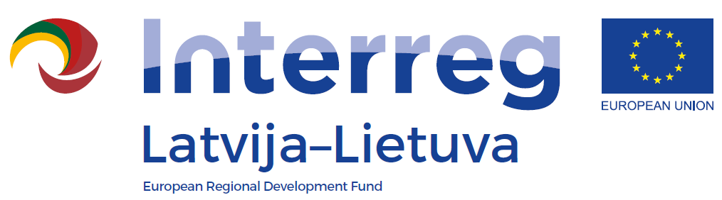
Seminar of the INTERREG V_A
Latvia-Lithuania Programme 2014-2020

LLI-110 Self-service libraries for different generations
Cross-border experience exchange workshop
AGENDA
Date: 18 September 2018
Venue: Siauliai City Municipality Public Library, K. Korsako str. 10, Siauliai
10.30 – 11.00 | Arrival, registration and coffee
11.00 – 11.10 | Welcoming
11.10 – 11.25 | Project and educational activities in Šiauliai City Municipality public library
11.25 – 11.50 | Educational activity "Learning languages with the foreign language learning program "Eurotalk ".
11.50– 12.05 | Educational activity "Glowing easel and sandboxing options".
12.05 – 12.30 | Educational activity "A close view of making a comic book " (from special toy parts made by 3D printer comics strips will be composed and photographed with an iPod device, and a comic book will be created hereafter).
12.45 – 13.45 | Lunch
14.00 – 16.00 | Creative educational activity ( Bibliography-information department of Šiauliai Municipality Public Library, Aido str. 27, Šiauliai)

